**Data Dictionary for**

**Smart للعقارات**

Openinig

Data is at the heart of every successful software development project, and it is essential to manage it effectively.

A data dictionary is a crucial tool for managing data in a project. It provides a comprehensive list of all the data elements used in the project, including their definitions, data types, and relationships with other data elements.

In this context, we will now present a data dictionary for our Apartment Rental project to ensure that our project team and stakeholders have a clear understanding of all data used in the project.

table of contents

1) Data Entities, Attributes, Constrains

1. Users

|  |  |  |  |
| --- | --- | --- | --- |
| **Attributes** | **Datatype** | **Length** | **Constrains** |
| **ID** | Bigint | 20 | Primary Key |
| **Name** | Varchar | 255 | Not Null |
| **Email** | Varchar | 255 | Not Null |
| **Email_verified_at** | Timestamp |  | Not Null |
| **Password** | Varchar | 255 | Not Null |
| **Is_admin** | Tinyint | 1 | Not Null |
| **Address** | Text |  | Not Null |
| **Number** | Varchar | 255 | Not Null |
| **Remember token** | Varchar | 100 | Not Null |
| **Created at** | Timestamp |  | Not Null |
| **Updated at** | Timestamp |  | Not Null |

2. Images

|  |  |  |  |
| --- | --- | --- | --- |
| **Attributes** | **Datatype** | **Length** | **Constrains** |
| **ID** | Bigint | 20 | Primary Key |
| **Unit ID** | Bigint | 20 | Not Null |
| **Image** | Varchar | 255 | Not Null |
| **Created at** | Timestamp |  | Not Null |
| **Updated at** | Timestamp |  | Not Null |

3. Reports

|  |  |  |  |
| --- | --- | --- | --- |
| **Attributes** | **Datatype** | **Length** | **Constrains** |
| **ID** | Bigint | 20 | Primary Key |
| **Unit ID** | Bigint | 20 | Not Null |
| **User ID** | Bigint | 20 | Not Null |
| **Created at** | Timestamp |  | Not Null |
| **Updated at** | Timestamp |  | Not Null |

4. Units

|  |  |  |  |
| --- | --- | --- | --- |
| **Attributes** | **Datatype** | **Length** | **Constrains** |
| **ID** | Bigint | 20 | Primary Key |
| **Description** | Text |  | Not Null |
| **Price** | Int | 11 | Not Null |
| **Type** | Varchar | 10 | Not Null |
| **For what** | Varchar | 10 | Not Null |
| **Date_of_posting** | date |  | Not Null |
| **Is available** | Tinyint | 1 | Not Null |
| **Posted by** | bigint | 20 | Not Null |
| **Parent_unit_id** | bigint | 20 | Not Null |
| **Created at** | Timestamp |  | Not Null |
| **Updated at** | Timestamp |  | Not Null |

5. Features

|  |  |  |  |
| --- | --- | --- | --- |
| **Attributes** | **Datatype** | **Length** | **Constrains** |
| **ID** | Bigint | 20 | Primary Key |
| **Air-condition** | Tinyint | 1 | Not Null |
| **Central heating** | Tinyint | 1 | Not Null |
| **bedrooms** | Int | 11 | Not Null |
| **Living rooms** | Int | 11 | Not Null |
| **bathroom** | Int | 11 | Not Null |
| **kitchen** | Int | 11 | Not Null |
| **Unit id** | bigint | 20 | Not Null |
| **Created at** | Timestamp |  | Not Null |
| **Updated at** | Timestamp |  | Not Null |

6. Parent-Units

|  |  |  |  |
| --- | --- | --- | --- |
| **Attributes** | **Datatype** | **Length** | **Constrains** |
| **ID** | Bigint | 20 | Primary Key |
| **Total floor** | Int | 11 | Not Null |
| **Num_of_units** | Int | 11 | Not Null |
| **Parent name** | Varchar | 255 | Not Null |
| **Has elevator** | Tinyint | 1 | Not Null |
| **Street name** | varchar | 255 | Not Null |
| **City name** | varchar | 255 | Not Null |
| **State name** | Varchar | 255 | Not Null |
| **Created at** | Timestamp |  | Not Null |
| **Updated at** | Timestamp |  | Not Null |

7. Notifications

|  |  |  |  |
| --- | --- | --- | --- |
| **Attributes** | **Datatype** | **Length** | **Constrains** |
| **ID** | Bigint | 20 | Primary Key |
| **Type** | Varchar | 255 | Not Null |
| **Notifiable type** | Varchar | 255 | Not Null |
| **Notifiable ID** | bigint | 20 | Not Null |
| **data** | text |  | Not Null |
| **Read at** | Timestamp |  | Not Null |
| **Created at** | Timestamp |  | Not Null |
| **Updated at** | Timestamp |  | Not Null |

2) Database Schema

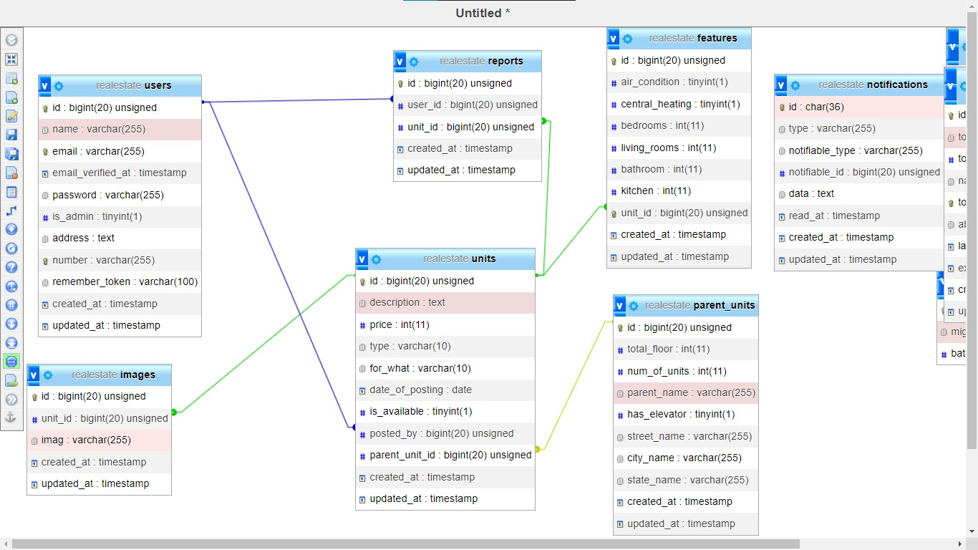

Conclusion

In conclusion, the data dictionary is a vital component of our Apartment Rental project, as it provides a comprehensive understanding of the data used in the system.

With a clear understanding of the data elements and their meanings, the project team can ensure consistency, accuracy, and completeness in the system.

The data dictionary will serve as a valuable resource for future updates and maintenance of the system.

By following the guidelines outlined in this document, we can ensure that the data dictionary is accurate, complete, and up-to-date.